EXPANSION OF VALUE AND FORM MUSICALITY AS

RITUAL TABOT BENGKULU

(Perluasan Nilai dan Bentuk Musikalitas Ritual Tabot Bengkulu)

¹Bambang Parmadi (FKIP University of Bengkulu)
(bepevanbencoeleen@gmail.com)
²I Gede Arya Sugiartha (Indonesian Arts Institute/ISI of Denpasar)

Abstract
The expansion of the value and form of musicality of the Dol as ritual Tabot music includes ideologi, musicality and new sociocultural into the performing arts extend to all elements of Bengkulu society generally. The transformation forms of Dol music as musicality are: sacred musicality becomes secular or profane. The physical form, function, and aesthetic of Dol music in Tabot rituals has an ever-increasing creativity development, musically progress and sosioculture-supporter progress. Dol music commodification is transformed into a new art identity from Bengkulu area. The development of musicality moves freely making change of sacredity ideology..
Problem analysis to reveal the problem used social practice theory, hegemonic theory, and popular culture theory, applied eclectically by using qualitative method. Data collection is collected and collected by observation, interview, and document study.
The research findings, there are forms of exploration and exploitation of Dol music from sacred to secular or profane and vice versa in the context of the commodification of physical musicality, function, and aesthetics in the identity ideology of the supporting community and the musical space dimension. The secular or profane Dol music permeates and indoctrinates the sacred Dol musical ideology as the musicality ceremony of Tabot ritual. The counter-assumption about sacred thing that will experience a shift into secular or profane is not entirely true for Dol music in Bengkulu.

Keywords: expansion, exploration and exploitation, Dol music, sacred and secular.

Introduction
Exploration is the process of field investigation activities for getting information and data collection conducted for research purpose and the provision of information to interested parties. Example: mining exploration, exploration of sound (music), dance exploration, and so on. Exploitation is any attempt or activity to perform excavations the potential contained in an object, the form of natural resources and others for the sake of individual needs or communal needs. Example: forest exploitation, child exploitation, cultural exploitation, and so on. Based on the defination, the exploitation tends to be negative, (https://kbbi.web.id; accessed 08 November 2018).
Exploration is an investigation or research to find a great thing or the possibility that has never existed with the target object source, so that knowledge material become increased and can acomodate the required information. Exploitation is an activity to acomodate the needs by taking or using existing material resources and most likely more likely disadvantageous.
In order to understand the form of exploration and exploitation on the transfomation of the Dol music tradition as ritual musicality, this study uses an ethnomusicology approach. Changes that occurs in the continuity of Dol music tradition toward the result of the formation of individual actions in social practice. The ethnomusicology approach seeks the musical form and musicality of Dol music in the sacred and social realm as folk music. Musicality is the element of music in expressing the ability to describe the definition/system, form, meaning, benefit, and listening (receiver) in the work of music. Another element in the work of music is the musical that view of the physical part of the music itself or the instruments that support it in the viewpoint of sociology and sociocultural ethnography.

Research methods
The method used in this research is qualitative method. Researcher deeply interviews the Tabot family, chiefs , related institutions, educational practitioners, and performing artists. Source of data obtained from primary data and secondary data. Primary data were obtained through deep interviews guided by interview guidelines and developed during the interview. Secondary data is used as primary data support.
To obtain complete data, this research uses purposive technique followed by snowballs technique (snowball). Instruments in this study is the researcher himself assisted by other tools. Data collection techniques: observation, interview, literature study, and document study. Data analysis techniques are data reduction, data presentation and conclusion. The technique of presenting the results of data analysis is done informally. Problem analysis to reveal the problem used social theory, hegemonic theory, and popular culture theory, applied eclectically by using qualitative method.
Based on the above explanation this research will describe and discuss about expansion of the value and form of the Dol as ritual Tabot music on musical transformation that includes; (1) musical from of Dol becomes secular or profane, (2) the physical form of Dol music, and (3) the function of value of Dol music.

Musical Form of Dol becomes Secular or Profane
The musical system in folk music of society is the object of the principal study of ethnographic musicology and ethnomusicology. Musicology in the ritual art musicality is the study of systems, functions, forms and meanings within or outside the culture, and ritual musical systems are object to deliver the goals of society itself. (Haydon in Supanggah 1995: 44-45). Folk music (tradition) as part of the quality of the conveyor intent on every ritual procession of the traditional community, becomes unity that support each other and can not be separated. In musical culture, a musical performance is understood as a message that has the cultural entity meaning organized under control of the rules. The music culture has been primarily dynamic thing rather than static, music has changed as response to encouragement both inside and outside, (Merriam, 1980: 4).
In the end, exploitation and exploitation make Dol profane/secular music a performing arts to fill ceremonial and entertainment events. So the meaning and form of ritual musicality that was originally as an expression of the war that occurred in Karabela have turned into a form of entertainment and creative resources for the community supporters.
Dol music was originally issued and played on 29 Dhulhijjah as a sign of notification and preparation to the community for entering the month of Muharram, the activity is the form of procession walking around the area where the Tabot family lives. Dol music game is performed by the group's music of Tabot families in their own places.
The sacred Dol music instrument is an ensemble set (Dol, Tasa, Suling, Keneng-keneng) equipped with great costumes of musicians and flags accessories or banners except when dharma Tabot, the musiciant does not wear full costume. In the ceremonies, sacred objects and this equipment is usually involved and become a unity ritual musical in several stages of Tabot ritual procession. In another case, secular or profane Dol music gives wide space to explore the musicality. Exploration of antraktive performance and Dol punching are dynamic and collaborating with musical forms or other instruments. This makes the actors and music artists freely explore music from Dol music.
The purpose of meeting the needs in the ritual to accompany the stages of the procession in order for the series of ritual ceremonies. Dol music serves as a ritual music packed with playing reportoar-Score traditional rhythm consisting of tam atam, suwena, and suweri that have philosophy meanin.
At this time there is a change of the rhythm pattern so that the philosophical meaning of each pattern of rhythm, rhythm and the song are shifted. Three grips of the rhythm pattern of Dol sacral music are developed into four beats in the sacred Dol music. The use of four rhythm patterns that are obtained from the results of this study, namely: at the first when (1) Tabot dharma rituals, mengambik tanah, and duduk penja, the players are only allowed to play suweri rhythm pattern only, while currently the player use at once three strokes rhythm pattern suweri, tamatam, and malalu. The score is played repeatedly and the form pattern rhythm is also changed. (2) the menjara ritual and meradai, just plays the rhythmic pattern of suweri and tam atam, while currently using rhythm pattern of suweri, tamatam, and melalu rhythm. (3) in the ritual of arak penja, arak serban, arak gedang and tabot tebuang, the players play the whole rhythm pattern of suweri, tam atam and suwena, currently the players play the rhythm pattern of suweri, tamatam, suwena and melalu. Today the Dol musical rhythm pattern develops and adds a rhythm pattern called melalu.
The explanation of several pieces of Score changes of the Dol music rhythm pattern as the musical gives fact that there is wide space to explore parts of the rhythm pattern as a creativity of artist and also make the musical Dol secular or profan more interesting and impressive.
The performing time of sacred Dol music in general have religious values ​​and should not be arbitrary, only at certain moments and places that are always associated with important events in the implementation of the ritual stage of Tabot ceremony in the first ten days of Muharram month. Performances of secular or profane Dol music can be anywhere not permanently defined, adjusting to existing events or when there is an order. Dol sacral music players only from the Tabot family who are allowed to play and are given the responsibility to always keep and care for the instruments that they play in the sixteen groups of sacred Tabot (Tabot Imam and Tabot Bangsal).
As a music player in a community group, he is considered to have advantages of these community groups. The musician also have concepts of behavior that can be imitated by other societies. So the attitude and actions of the community are reflected in the music itself as a tradition that upholds local ethics (Merriam 1964: 46-47). Based on Merrian, it is concluded that the Dol music player in Tabot ritual ceremony has advantages of other community groups, \as the character and actions will be influential in the pattern of life of the people who love it. Unlike the musicians from secular or profane Dol music, it is according to his needs. Secular or profane Dol music players have no limits, ranging from children / students, teenagers, even women.
The development of the exploration and exploitation of Dol music from sacred to secular or profane in the study of the transformation of the art of music often occurs, because the secular or profane Dol music in general is to give the ability to express and appreciate the art creatively for development and provide balanced emotional attitudes on the community supporters . Dol secular or profane music forms a tolerant character, socialization, democratic attitude that includes sensitivity to the environment to be creative. In other words Dol Music plays an important role to help the development of cultural dynamics of performing arts that impact on the growth of mind, thought, socialization, and emotional in society. Dol secular or profane music emphasizes more on giving the experience of musical art, which will give birth to the ability to utilize Dol music in life with new ideas. The goal is to have a sensitive capability to the natural environment and to utilize his experience to communicate creatively through artistic activities in an effort to uphold local cultural values ​​and not to forget the value of the sacred tradition.

Treatment of Physical Dol Music
Physical Dol music change makes the displacement of values, treatment, and appearance gettin very complex. The change physical shape of Dol music instruments both in the musicality and on the sosoisokultural in Bengkulu City because the value and function of the music have shifted. The issue of musical elements in the musicality in outline is the musical instrument and the community of actors and connoisseurs, which includes changes in the form of treatment of instruments and forms of Dol music instruments.
Dol music as sacred music not only in the element of the musical rhythm pattern undergoing changes, exploration and exploitation of the treatment of the instrument itself shifts as a goal of creativity. This sacred music instrument is treated by the family of Tabot with a very regular and customary nuanced and exalted. Over time, the development of Dol music changes also experienced a commodification of changes to the form of treatment on the instrument. The exploitation of Dol music becomes so free to be an antraktive creativity material. Dol which was once sacred and has been exploited at this time has become the material exploitation and musical exploration for artistic purpose of stage and aesthetic performances creations.
Explains that the sacred music and Dol instruments are changing meaning and value when Dol's music is brought to the realm of creativity, while in playing and treating sacred tools must be with customary rules. But in fact, Dol's music and instruments are something that can be explored and exploited in such a way that it becomes a very attractive and interesting charming the audience and the government to legitimize it as a new cultural asset and identity.
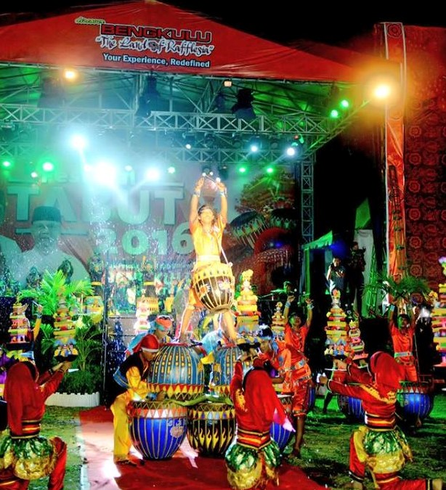
Treatment of Dol instruments as performances (Doc.: Bepe 2015)
Physical changes also occur on the instrument appearance, to provide an artistic appeal in the form of a Dol instrument. Physical appearance outside of sacred Dol is tinged with shades of bright colors such as black, red, green and bright yellow to make it look more attractive. In the body part (kelawang) Dol is formed a triangular field with striking colors, the shape of the newly grown bamboo shoots (bamboo shoots) is a carved image or a typical Malay Bengkulu. Triangle bamboo shoots Kelawang of Dol has a philosophy meaning . Black means mourning, red means the valor and courage, fortitude and coolness mean green, and yellow means the glory and heroism.
Currently, for the purpose of creativity, the instrument Dol looks more artistic, kelawang of Dol is drawn in such a way. From interviews with one of the artists Dol Bengkulu, said picture ornamentation on kelawang Dol is a form of creative ideas of the artists music tradition in Bengkulu, in order to look better and beautiful instrument when played on stage both day and night. Especially when appearing at night bring an artistic color due to the effects of the light of the stage.
It is more crucial to the material of body construction (kelawang) of Dol made by the head of KKT (Tabot family) from coconut tree become fiber material. From the interviews with the head of KKT, said that currently to get the materials kelawang Dol (coconut tree) is very difficult and quite rare, and also to streamline the time and energy play music Dol, kelawang Dol modified to be lighter when takeken and played it when the rituals of meradai, menjara, arak gedang wine, and Tabot tebuang. So that in making Dol run of fiber material that is printed like kelawang coconut tree.
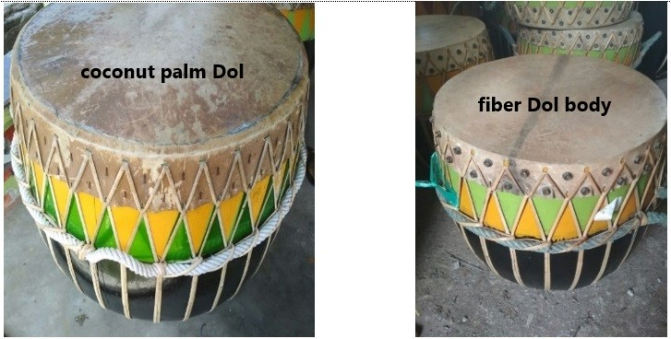
At a glance there is no the difference in the external physical form between fiber and coconut tree material, but the sound is very different. Dol instrument made of fiber produces loud sounds more, Dol instruments made from coconut trees are voiced bass more (low). In addition, the effect of sound produced is also due to different membrane stretching techniques, Dol instrument made from coconut trees stretched by using a flexible rattan webbing and interconnected assisted by nails or pegs to hold it. While the Dol instrument made of fiber, the membrane is only held with several bolts around it so that the membrane strain does not last long (heated every time it will be played) and wicker rattan only as decoration or patch just to look the same as the original. The dynamics of the phenomenon of the above changes in the view of modernization generally assume that the sacred tend to be secular or profane, but not with the changes that occur in the element Dol music turns out to be otherwise. This means that the notion of full modernization can be used especially in the transformation that occurs in Dol music.

Expansion of Dol Music Function
Function and use is a very important issue in ethnomusicology, because it involves the meaning of music, it is not just facts about music but more than that, to know the implications of music on humans, and how these implications are produced ( Merriam, 1980: 10). Dol music began to develop by itself for certain purposes. This encouragement is reinforced by the discourse of the promotion of cultural tourism typical of Bengkulu region in the 1990s. The provincial and municipal governments of Bengkulu made policies on cultural and natural tourist destinations in line with the decision of the Minister of Tourism and Telecommunication Soesilo Sudarman in 1992. Started from the cultural activities of Bengkulu in the 80's. The teachers and students of Karawitan Indonesia Secondary School (SMKI) Bengkulu hold cultural arts activities with Dol theme and music material to be modified, created and collaborated. Continuous innovation and exploration develops so that secular or profane Dol music can at any time be displayed by art galleries, schools or anyone else.
In every event the celebration of Dol music as Tabot ritual musicality is usually held the additional events as a tourist attraction and art gallery activities. Topologically Dol music can be grouped in two packs, first, it appears to be more total ritual art, called the art of ritual music because during the procession and all the infrastructure including the property and its accessories, it is not disturbed by the audience or the people, the person involved in the role as the perpetrator and the ritual procession (Tabot family only), while the second, the pack is more in order or can be called as an order and the art of spectacle (secular or profane). The audience who attend no more than just enjoy the entertainment. It only because just for total spectacle or entertainment there is no content of ritual elements and is only of interest purposes.

As a Culture of Popular Music
In the discussion of the Perspective of popular culture, to facilitate the unraveling of how the commodification of Dol musicality as a popular performing art. Dol music performance transformed into music instruments and ensemble creation which is more energetic with very aggressive as a form of contemporary music. When the instrument is joined by more popular music such as pop music and jazz music. The performance of Dol music composition was appreciated by the electric guitar and the bass guitar with Dol attractions. The different forms of music are no longer visible that Dol music comes from ritual ceremonies. This habits become part of the activities that continue in the city of Bengkulu until now. Especially for the artisans and the community becomes a creativity that provides the feeling of creating a musical composition with Dol instrument material, one of them by colaborate Dol music with modern or western music.
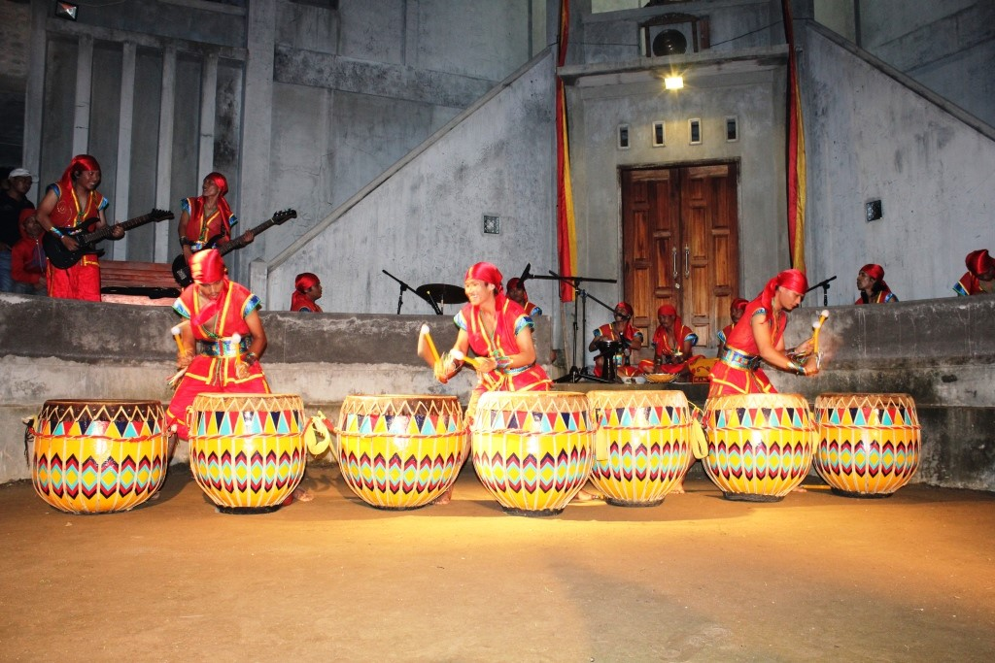
The commodification of Dol music performances as popular music also develops in a new generation (children). Packaging work on a more attractive and antraktive invite the purpose of creativity, and more importantly as a cultural media campaign more interesting because played by children. This commodity helps the government indirectly to promote traditional music of Bengkulu out. There are some Dol music show by children that have been followed, one of which is the Traditional Music Festival Anak Nusantara at GKJ Jakarta 2009 and get the nomination of the best music material, and the appearance of children with the new Dol music composition that is more of a creativity and entertainment.
Then among students such as PGSD community Artcre Bengkulu University also do not want to miss, It is the only one community or music art studio consisting of majority of women featuring works of Dol music composition that always colaborate Dol music with vocals, speech, poetry and school music ensambel (pianika and recorders). Some of their works have been performed at Singapore Art 2012, Payakumbuh World Music Festival 2013, Cross Culture Percussion in Padang West Sumatera 2015. In addition sanggar Arastra Bengkulu is very exist in exploring the material of Dol instrument as a musical composition percussion with other popular music. In 2016 they show their latest work "Dol Buai II" at the International Forest Festival Festival in Sarawak East Malaysia. This work colaborate Dol music with Queen group bands and middle eastern melodies.
Another change in Dol music as a popular music culture penetrated the world of recordings, Dol Instruments colonized with modern musical instruments such as flute, keyboard, guitar, cajon, djembe, and others. Apart from being a recording material of new musical compositions, Dol instrument is also used to fill music on Bengkulu region songs and modern dance music. As did the art community of JEnsambel or Jengkal theater in the picture beside. Creativity recording is not only done by JEnsambel community alone, generally recording studios in Bengkulu do it. The use of Dol music in the recording world is usually to fill the music of regional songs or Bengkulu Malay songs
From some explanations and pictures above is the breadth or freedom of exploration Dol music as a culture of popular music in the creativity of the identity of local wisdom. The exploration of Dol rhythm motive and laying-stage design make the performers and art music artists very freely to exploit and explore the musical from Dol music. The material of musical composition with various new arts as a form of popular music culture aimed only for creativity, entertainment and order. The irony sometimes does not consider the meaning of Dol musicality as standard of tradition and ritual. The role of government as the power of policy provides a space for the growth of popular culture in the music of the results of Dol exploitation and experimental music.

As a Media Means of Purpose
Political cultural strategies that can observe, predict, and address the development of Dol musical culture as Tabot ritual musicality to remain sustainable. To support the implementation of the politics of cultural strategy, the relevant local cultural infrastructure is controlled by the government, related institutions, and the Tabot family itself, need to be empowered. In other words, the associated local cultural infrastructure must have a special cultural assessment program. The need to establish a new activity, such as a cultural assessment institution, in Bengkulu does not seem to exist. In general, cultural assessment institutions that exist controlled by universities in Bengkulu who are interested in the studies of the local culture.
Dol music as musicality performs the entertainment duties of promoting and marketing various products of local traditions and interests of power. The mission of development as a conservation of Dol Music itself is done through the provision of free space for creativity and promotional events, festivals, as well as anticipation at Dol, Dol dance competition, and so on. However, there are still other substantial missions that are still forgotten in the package of activities, namely the development and preservation of the spirit of Dol music as Tabot ritual musicality symbolizes the social contestation. It should be through Dol's music a commitment, and a sense of belonging to raise the value of prestige of local wisdom. Likewise with the purpose of the policy giver of government institutions or related institutions, by looking at the development of Dol music they take the opportunity to facilitate and provide rules under the guise of preservation and promotion of local cultural identity. To bring up a new ideology showing such as; Dol music festivals, tourist destinations, educational policies, and promotional events received by the public.

Conclusion
The interconnection of all phenomena that occur from the exploration and exploitation of Dol music both socioculturally and musically in itself is very obviously influential on the shifting of local sociocultural meaning. The phenomenon of function transformation in the sacred music of Dol as part of the cultural life that occurred in the city of Bengkulu in particular and the province of Bengkulu generally. The emergence of a system of values ​​and beliefs embedded in the life of the people of Bengkulu City is a form of a representation. The discussion of the form of Dol's musical value system as a musical and sociocultural is expected to have a positive impact on the local identity ideology that underlies the growth of the arts.
The exploration and exploitation of Dol music in its culture makes a cultural shaping with far-reaching implications, including the dimensions and cultural elements associated with sociocultural with horizontal and vertical scale enlargement. Making cultural transformation leads to a very complex change. In cultural change give new order in every social activity. This change can affect the form or dimension of culture, the idea that becomes the core of culture consisting of cultural values ​​that are the result of the experience astronomy from supporters; behaviors that control human attitudes and behavior; physically consisting of human objects and equipment (Reed in Turner, 2012: 642).
In the study of exploration and exploitation of the art of music this is legitimate, because the secular or profane Dol music in general is to give the ability to express and appreciate the art creatively for development and provide attitudes emotionally balanced on the support community. Dol secular or profane music forms the character of discipline, tolerance, socialization, democratic attitude that includes sensitivity to the environment to be creative. Dol exploration and exploitation plays an important role in assisting the development of cultural dynamics of performing arts that impact on the growth of mind, mind, socialization, and emotional in society. Makes Dol Music secular or profane more emphasis on giving the experience of music art, such as the material in learning in the field of school education and studio, also provide the artists or artists with the opportunity as a source of ideas and ideas. The goal is to package and produce a new form of value in the world of popular music culture as an aesthetic and commodity experience (both economically, creatively, and the interests of power). By Dol's musical changes to communicate creatively through policy activities, learning, and artistic creation in an effort to uphold local cultural values.

Acknowledgment
The author would like to thank the distinguished Prof. Dr. I Gede Arya Sugiartha, S.SKar, M. Hum., who has been willing to guide the author in completing this research. The managing team E-jurnal Indonesian Arts Institute of Denpasar, authors thank you already willing to a publish this paper. The research that is described in this paper were made possible by the government of Bengkulu and all of the participant.

Bibliography
Ammer, Christine. 1973. Harper’s Dictionary of Music. New York, Hegerstown, San Francisco, London: Barnes & Noble Books.
Bourdieu, Pierre. 2015. Arena Produksi Kultural: Sebuah Kajian Sosiologi Budaya (terjemahan). Bantul, Yogyakarta: Kreasi Wacana.
Bungin, Burhan (ed), 2008. Metodologi Penelitian Kualitatif. Jakarta : Raja Grafindo Persada
Gramci, Antonio. 2001. Catatan-catatan Politik. Surabaya: Pustaka Promethea
Merriam, Alan P. 1980. The Anthropology of Music. Evanston , Illinois: Northwestern University Press.
Nettl, Bruno and Philip V. Bohlman. 1991. Comparative Musicology and Antrophology of Music. Chicago and London: The University of Chicago Press.
Ritzer, Goerge – Douglas J. Goodman, 2003. Teori Sosiologi Modern. Jakarta : Prenada Media
Sanderson, Stephen K. 2011. Makrososiologi. Jakarta : Raja Grafindo Persada
Strinati, Dominic. 2007. Popular Cultural: Pengantar Menuju Budaya Populer (terjemahan). Yogyakarta: Penerbit Jejak.
Storey, John. 2010. Cultural Studies dan Kajian Budaya Pop. Yogyakarta: Jalasutra.
Supanggah, Rahayu (ed). 1995. Etnomusikologi. Yogyakarta: Yayasan Bentang Budaya.
Tilaar, H.A.R. 2003. Kekuasaan dan Pendidikan: Suatu Tinjauan Dari Perspektif Studi Kultural. Magelang : Indonesiatera
Waesberghe, F.H Smits van. 2016. Estetika Musik. Yogyakarta: Thafa Media
Zacky, Antony. 2003. Menguak Tabir Misteri Tabot Lewat Naskah Kuno. Bengkulu: PT Rakyat Bengkulu.

